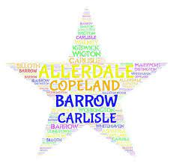

**South Whitehaven Family Hub, Whinlatter Road, Whitehaven, CA28 8BN**

**T:- 01946 64600**

**Millom Family Hub, Lapstone Road, Millom, LA18 4LP T:- 01229 777592**

**Egremont Family Hub, Southey Avenue, Egremont, CA22 2HH T:- 01946 823896**

**North Whitehaven Family Hub, Main Street, Hensingham, CA28 8QZ**

**T:- 01946 690067**

**For more information, advice, groups or activities which may be of interest**

**you can also visit our website at:**

[**www.family-action.org.uk/what-we-do/children-families/0-19/**](http://www.family-action.org.uk/what-we-do/children-families/0-19/)

**or visit our Facebook page at:**

**https://www.facebook.com/CopelandSupport**

**What’s On Guide**

**January – March 2022**

Welcome to our latest newsletter where you can find lots of information about the sessions and activities running within your local community over the next few months.

We would like to welcome all families who have registered with us this year. We feel it is important to be able to continue to provide families with support during this challenging time. **Our teams are continuing to deliver support in a variety of ways and we are now offering many sessions face-to -face in most of our Children’s Centres.** Covid-secure procedures are in place at each centre.

**Groups will restart in the New Year the week beginning 10th January 2022**

We are available to contact if you feel in need of support or would like further advice or information; you can get in touch by contacting one of our centres, below:-

**Bumps to Babies**

Bumps to Babies is a group which will provide parents/carers with babies aged **0-6 months** with the opportunity to share their experiences and learn about basic development, such as typical sleeping patterns, physical development, crying (communication and language) and milestones your baby may reach during this time period. The sessions will be based on your interests, or needs of these topics. The sessions will also allow you to connect with other parents/carers in the local area.

**South Whitehaven** – Thursdays @ 10.30 - 11.30am

**Egremont-** Tuesdays @ 1 -2pm

**Millom -** Thursdays @ 1 -2pm

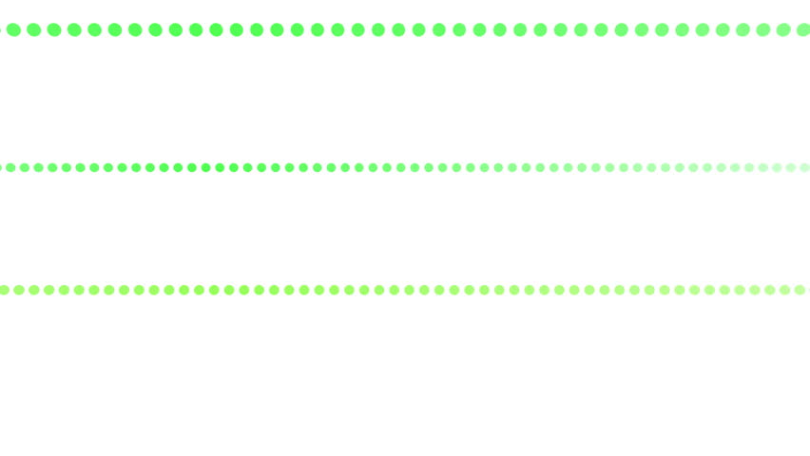

**Baby Sensory**

These baby sensory sessions are suitable for parents and babies **6 months +**

Join us for sensory play, songs and rhymes. A safe place to meet other parents and spend time with your baby. Sensory play enhances your baby’s learning, creativity and imagination. It’s an opportunity to build a secure bond with your baby through engaging play.

Due to the nature of the group we recommend bringing a towel and extra clothes- we do get messy!

We do use food products for some activities, please inform us of any allergies or intolerances.

**South Whitehaven** Tuesday 10am-11am

**Egremont** Tuesday @ 10.30am- 11.30am

**Millom** Mondays @ 10am- 11am

**Please contact the following for more information. These are drop-in sessions but please be aware places are limited**

**Egremont – email** [**eleanor.cummings@family-action.org.uk**](mailto:eleanor.cummings@family-action.org.uk)

**or telephone 07815688396**

**Millom – email** [**louise.gregg@family-action.org.uk**](mailto:louise.gregg@family-action.org.uk)

**or telephone 07563021741**

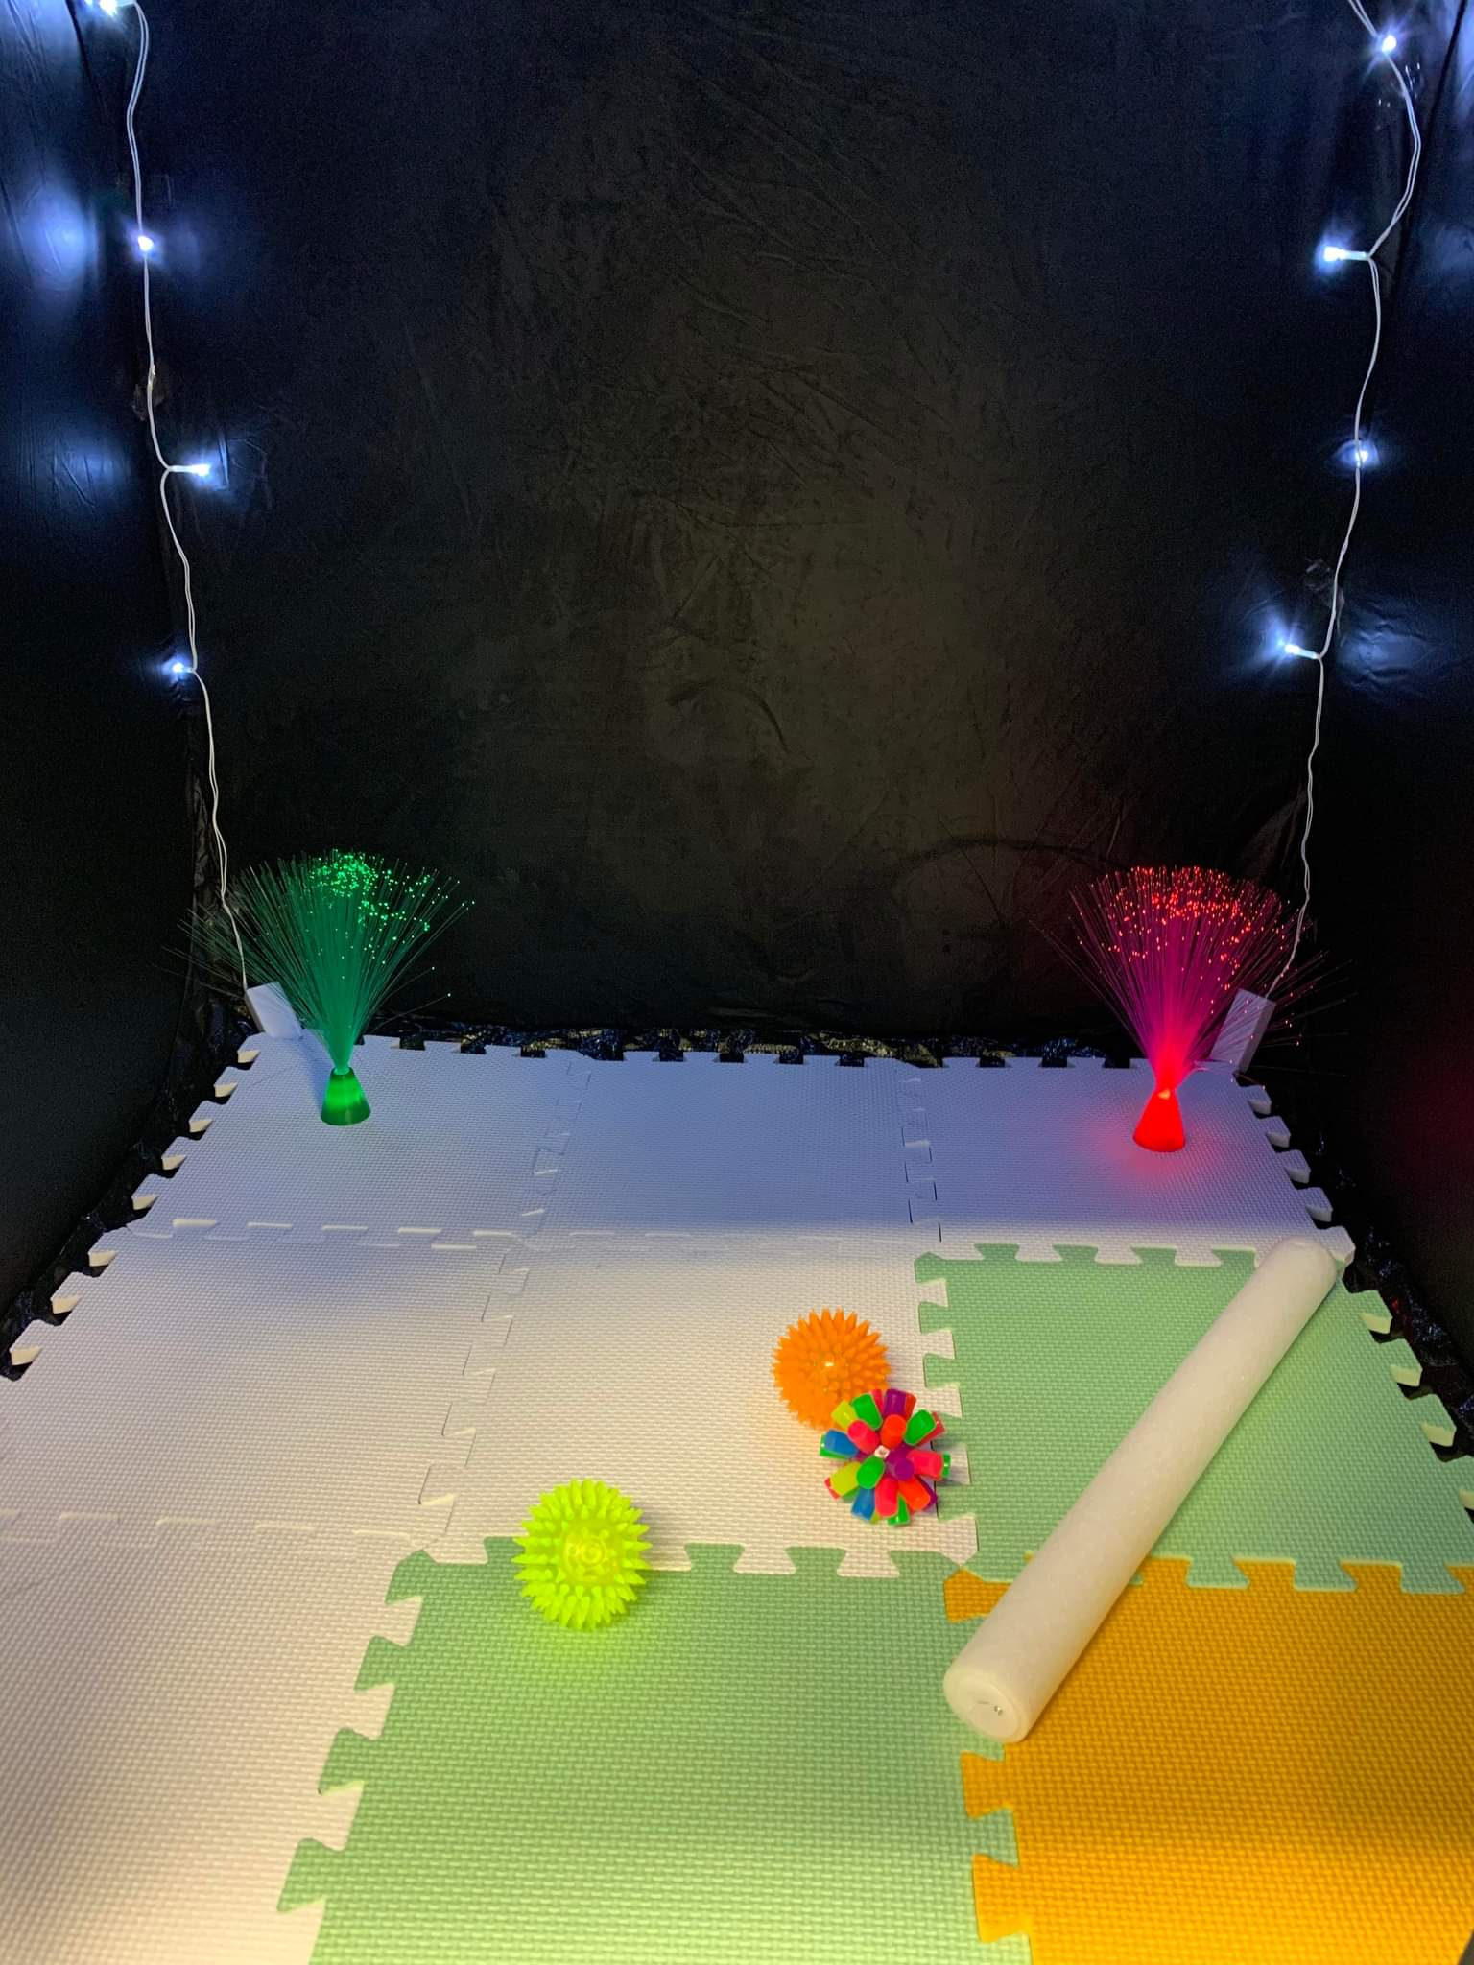**



**Little Explorers: 1-2’s**

Little Explorers is a group which provides children age between one and two with the opportunity to grow and learn with other children in the community. The sessions will be fun and exciting, with lots of role play experiences, mark making, crafts and messy play, which are all themed around well-known books and stories. The sessions will also allow parents and carers to connect with others in the local area.

If you are interested, please feel free to attend our drop-in service within one of our centres.

**South Whitehaven Children’s Centre:** Monday @ 11am- 12pm

**Egremont Children’s Centre:** Fridays @ 1-2pm

**Millom Children’s Centre:** Tuesdays @ 1.30-2.30pm

**Little Learners**

Come and join us for some exciting Mini Makers sessions. The sessions will use sensory play, role play and exciting activities to help children develop school readiness skills. The sessions will help support fine and gross motor skills, listening, and communication and language skills. We will engage in songs and rhymes, stories and fun sensory activities together.

Suitable for ages **2-5 years**

**South Whitehaven** Thursdays @ 4pm

**Egremont** Mondays @ 2pm

**Millom** Mondays @ 1.30pm and Fridays @ 1pm

**Please contact the following for more information about**

**the sessions at your local children’s centre. Places are limited.**

**South Whitehaven -** **email** [**christina.thurston@family-action.org.uk**](mailto:christina.thurston@family-action.org.uk)

**or telephone 07815688314**

**Egremont – email** [**eleanor.cummings@family-action.org.uk**](mailto:eleanor.cummings@family-action.org.uk)

**or telephone 07815688396**

**Millom – email** [**louise.gregg@family-action.org.uk**](mailto:louise.gregg@family-action.org.uk)

**or telephone 07563021741**

**Let’s get physical**

These sessions are aimed at children aged 2-5 years.

In Little Learners: we talk about the importance of healthy eating and physical exercise. We follow this by fun dance and yoga activities. The aim of these sessions is to promote movement and physical exercise to help children’s natural development.

Tuesday 20 April @ 4.30pm (for 4 weeks)

All of the sessions will be virtual accessed via **Zoom**

**Please contact Eleanor Cummings by email on** [**eleanor.cummings@family-action.org.uk**](mailto:eleanor.cummings@family-action.org.uk) **or by telephone 07815688396 for more information or to book onto the sessions.**

**SEND Support Group**

Our SEND support group is an opportunity for you and your child to attend fun activities, whilst meeting parents and carers in the local community.

This group is aimed at children age 0-6 years, who have a diagnosed additional need (both physical and educational) or if you are worried about any of your children’s needs and require advice and support from us and other parents or carers. The group will be full of fun activities, sensory play and opportunities for you to share your experiences, or to get advice or any support needed.

The sessions are drop-in and booking is not needed.

**South Whitehaven** – Tuesdays @ 1pm-2pm

**Please contact the following for more information**

**Christina Thurston - email** [**christina.thurston@family-action.org.uk**](mailto:christina.thurston@family-action.org.uk) **or by telephone** **07815688314.**



**Great Expectations **

Our new 5 week antenatal group is suitable for all expecting parents. The course will cover the baby brain, birth expectations, safe sleep and routines, infant feeding and attachment and emotional wellbeing. This is a safe, confidential space to make friends and gain support and our facilitator will also be able to answer any questions throughout.

**South Whitehaven** Fridays @ 1pm-2pm

**Egremont** Wednesdays @ 11.30am-12.30pm

**Millom** Fridays @ 10am-11am

**To book places on any of the above sessions please contact:-**

**South Whitehaven- email** [**christina.thurston@family-action.org.uk**](mailto:christina.thurston@family-action.org.uk) **or 07815688314.**

**Egremont – email** [**eleanor.cummings@family-action.org.uk**](mailto:eleanor.cummings@family-action.org.uk) **or 07815688396**

**Millom – email** [**michala.tyson@family-action.org.uk**](mailto:michala.tyson@family-action.org.uk) **or 01229 777592**

**Infant Feeding Group**

Infant feeding Support is a group for those that are breastfeeding, or are thinking about breastfeeding, and also for mothers/carers who are feeding using formula. With the support of a trained Infant Feeding worker, parents are offered support and advice both from the Family Action practitioner, and each other.

**These are drop-in sessions so just pop along.**

**Egremont** Thursdays @ 12pm - 1pm

**Millom** Fridays @ 11.00am – 12.00pm



**Infant Massage**

Infant Massage is the gentle, rhythmic stroking of your baby's body using your hands. As part of a massage routine, you might gently manipulate your baby's ankles, wrists and fingers. There is widespread belief that infant massage can increase a parent/carer’s awareness of their baby’s needs, supporting an early bond, as well as improving their sense of wellbeing. It can also provide baby with relief from colic and constipation as well as promoting relaxation, and longer sleep.

**Sessions are available at our South Whitehaven, Egremont and Millom Centres and are a 5 week programme.**

**To book a place please contact** [**alice.murphy@family-action.org.uk**](mailto:alice.murphy@family-action.org.uk) **or ring 01229 777592**



**Domestic Abuse Recovery Toolkit**

**The Domestic Abuse Recovery Toolkit is a 12 week course to support ladies who have experienced  a domestic abuse relationship.**

**If you have left your abusive partner but find that you continue to be personally/emotionally impacted then the Domestic Abuse Recovery Toolkit can help. It will support you to develop a toolkit of positive strategies that will aid your road to recovery.**

**Ladies who have completed the course in the past have provided very positive feedback and would strongly encourage others to attend –**

“I have overcome fears, developed an understanding of behaviours to prevent me being in the same situation and my confidence has boomed. I am now looking forward to a  positive future with my little ones, where I am not always so anxious.”

“I would whole heatedly recommend this course. The knowledge I have gained is invaluable. I am a different person from what I was at the beginning of the course, I am much more confidant and value myself. Remember the first week may seem daunting but you won’t regret it.”

**Please contact Johanna Smith by email on**

[**johanna.smith@family-action.org.uk**](mailto:johanna.smith@family-action.org.uk)

**or by telephone on 07815688469**

**for more information and when the next programme will begin.**

Children and Young Person Recovery Toolkit

An 8-week course for **Children & Young people** who have experienced/been exposed to domestic abuse and who are no longer living with the abusive parent/carer.

The aims of the programme are to help children and young people come to terms with their experiences and develop positive lifestyle and coping strategies.

Please complete a referral or contact either

Kirsty Treen or Rachel Sheard – 01229 777592 to discuss further

[**kirsty.treen@family-action.org.uk**](mailto:kirsty.treen@family-action.org.uk) **or** [**racheal.sheard@family-action.org.uk**](mailto:racheal.sheard@family-action.org.uk)

**Decider Skills**

The Decider Skills is Cognitive Behavioural Therapy to teach children, young people and adults the skills to recognise their own thoughts, feelings and behaviours, enabling them to monitor and manage their own emotions and mental health.

There are 12 skills they will be taught to help manage feelings and emotions with a workbook to make their own as a supportive tool.

**Please contact your local Centre for more information and advice as to start dates for the next sessions.**

 





Family Action Copeland are offering a 4 week Barclays Life Skills course which will cover CV’s and job searches, Personal Skills and Money Skills in an interactive group for Year 11 students.

**Millom Family Hub** from Wednesday 12th January 4pm-5pm

For more information or to register for the group please either email [alice.murphy@family-action.org.uk](mailto:alice.murphy@family-action.org.uk) ring 01229 777592 or pop into the centre for a chat. Parental consent is needed but parents do not attend the group.



**Let’s Get Talking**

Let’s Get Talking is a six-week programme which supports communication and language development in partnership with the Speech and Language Team.

This group is suitable for children **aged 2 to 4 years** with few or no single words, and no other concerns regarding special educational or developmental needs.

**Please contact Christina (South Whitehaven) on:** [**christina.thurston@family-action.org.uk**](mailto:christina.thurston@family-action.org.uk) **or by telephone 07815688314 or Eleanor (Egremont)** [**eleanor.cummings@family-action.org.uk**](mailto:eleanor.cummings@family-action.org.uk) **or by telephone 07815688396 or Louise Gregg (Millom)** [**louise.gregg@family-action.org.uk**](mailto:louise.gregg@family-action.org.uk) **for more information on the sessions.**



**Solihull Parenting Course**

The Solihull parenting group is for parents/carers who want to know more about sensitive and effective parenting. It aims to develop a framework of thinking about child/parenting relationships to:

* Promote understanding of children’s behavior within the context of developmental issues
* Promote the development of parent/child reciprocity (being in tune with your child’s needs)
* Increase confidence and self-esteem in both parents/child relationships
* Give parents a strategy for repair when things go wrong
* Develop a framework of thinking about parent/child relationships which can develop into a lifelong skill
* Promote reflective, sensitive and effective parenting

**Please contact Kirsty Treen by email on Kirsty.treen**[**@family-action.org.uk**](mailto:andrea-clarke@family-action.org.uk) **or by phoning one of the Centre’s for more information and when the next programme will begin.**

**Adolescent Girl’s Group**

Copeland families: We will be running a six week informative and supportive group for adolescent girls ages 11-13. The group aims to boost self-confidence whilst being aware of a variety of relevant topics to this age group in a non-judgemental environment.

The topics include:

**Online safety**

**Emotional resilience and anxiety**

**Puberty**

**Drugs, alcohol and peer pressure**

**Healthy eating and cooking**

**Arts and crafts / celebration of success**

Sessions will run at **South Whitehaven Children’s Centre,**

**and will begin** **Wednesday 19th January 2022 @ 4.00- 5.30pm for six weeks.**

If times and dates are subject to change, you will be notified.

If you are interested or know anyone to be referred to this group, please contact Nicola on [Nicola.Tyson@family-action.org.uk](mailto:Nicola.Tyson@family-action.org.uk) or Christina on [Christina.Thurston@family-action.org.uk](mailto:Christina.Thurston@family-action.org.uk)



**Cook-a-long**

A virtual family cook-a-long for families to learn cooking skills, new recipes, learn healthy eating key messages and to engage in family bonding time.

Ingredients will be dropped off at your door and a ZOOM link sent prior.

Booking essential for block to secure space but are limited.

Tuesdays 4.30pm- 5.30pm (**beginning**Tuesday 11th January 2022)

Please contact Christina on [christina.thurston@family-action.org.uk](mailto:christina.thurston@family-action.org.uk) to book a place.





Family Action Needs YOU!!

Could you be a volunteer with us?

Volunteering has been at the heart of Family Action since we were established in 1869, run solely by volunteers.

As a volunteer you will gain valuable skills and experience working as part of a team making a real difference to the lives of children and young people in your area. With access to a comprehensive learning package, we can help you achieve this with continued support and training.

Looking to gain experience whilst studying or to gain full-time employment? We have lots of flexible options with both short and long-term positions available**.**

**There are lots of ways you can give your time; please contact me to find out more information!!**

**Emma Moorhead, Volunteer & Community Engagement Worker**

**Tel: 01946 64600**

**Mobile: 07815686953**

**Email: [emma.moorhead@family-action.org.uk](mailto:emma.moorhead@family-action.org.uk)**



**FamilyLine**

Family Action’s FamilyLine is a **FREE** helpline for all members of the family over the age of 18.. FamilyLine provides support on all aspects of family life, from befriending to counselling services.

Available: Monday – Friday, 9am – 9pm

Contact our helpline by telephone: **0808 802 6666**

Text: **07537 404 282**

Email: [familyline@family-action.org.uk](mailto:familyline@family-action.org.uk)

Visit [www.family-action.org.uk/familyline](http://www.family-action.org.uk/familyline)

**A live chat is also available on our website**



