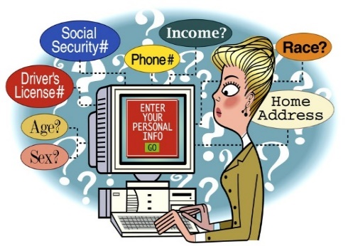
Your Data
Solihull SENDIAS will collect information about me to help support me & give me a service.
Solihull SENDIAS will request my consent to collect & use my data/information

Please tick the box if you agree, if you do not agree, leave the box empty.
- I understand that everything I talk about, is between me & Solihull SENDIAS; this is called confidentiality.
- Solihull SENDIAS will not tell my parent(s) information that I have told them.
- I understand that SENDIAS might need to contact someone in an emergency or if someone is in danger.
- I have told SENDIAS about any conditions that I may need support with.

Consent: Tick the box if you agree, if you do not agree, leave the box empty
I give my consent for Solihull SENDIAS:
- to help support me with their service
- to collect & use my data/information
- to help identify the support I require, to share/speak to school, health, local authority.
- to take part in Solihull SENDIAS surveys & give my views
- to tell Solihull local authority & health about the services I receive (my name will not be shared in these reports)
Questions about support
If I have a question about my support from Solihull SENDIAS, I should contact the manager Hazel:- hazel.clarke@family-action.org.uk 0121 516 5173.
If I cannot talk to Hazel Clarke, I can contact Charmaine Church Charmaine.church@family-action.org.uk to discuss my concerns

My Name……………………………………………………….……………………………………age …………..
My Phone number ……………………………………………………………..…………………………………….
My email address …………………………………………………………………………….………………………..
Do you wish us to use your phone or email to contact you …………….………….……….
Emergency contact name………………………………………………………..…………………………………..
Relationship to me ………………………………………….……………………
Their contact details ……………………………………………………………………………………………….…

Sign your name here:………………………………………………………………...…………………………………….. (this is for the consent above) date:…………………………………………

