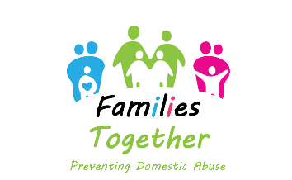
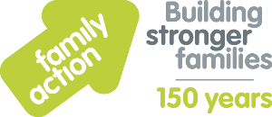
Referral to Families Together Programme (FTP) – Sandwell
Before completing this referral please ensure that you have referred to the Guidance Notes PDF Document
Please ensure that all fields of this referral form are completed - if not, the referral shall be declined
REFERRING OFFICER DETAILS
Full Name
Service / Agency
Contact Details
(Telephone Number & Work Mobile, E-Mail Address & Postal Address)
CLIENT DETAILS
Full Name
E-Mail Address (We will use this to send their acceptance letter & end of Programme report)
Postal Address
Telephone Number(s)
Ethnicity
First Language
Age / DOB
Any known Disabilities
Any known Risk Factors e.g is this person a perpetrator of DVA
Any Alcohol / Substance Misuse issues
Any Current / Previous Criminal convictions
PARTNERS DETAILS
Full Name
E-Mail Address (we will use this to send their acceptance letter & end of Programme report)
Postal Address
Telephone Number(s)
Ethnicity
First Language
Age / DOB

Any known Disabilities
Any known Risk Factors e.g is this person a perpetrator of DVA
Any Alcohol / Substance Misuse issues
Any Current / Previous Criminal convictions
CHILD/REN’S DETAILS
Name(s)
Age(s) / DOB(s)
School / Nursery Details
Relationship (e.g. step-children)
REASON FOR MAKING REFERRAL? Please detail why you are making this referral, e.g. any incidents, relationship break-down, reason for social services intervention with family etc.
PREFERRED TIMES OF ENGAGEMENT (e.g. any working commitments of parents)
Please place an ‘X’ next to the clients preference from the options below:
- Evening Group
- Day-time Group
- 3 x telephone sessions, including DVA awareness and signposting

This referral will not be accepted unless both parents have wet signed/verbally agreed to the referral.
CONSENT OF PARENT(S) to engage with Family Action and to allow Family Action staff to make contact with them soon after referral to our service.
Client’s Full Name
Signature
Partner’s Full Name
Signature
Date

*** End of Referral Form ***

